**Lab - How to create a hold in a Core eDiscovery case?**

* **Step 1:** Navigate to the Security and Compliance center
* **Step 2:**Click “Core eDiscovery” under the “eDiscovery” drop-down on the navigation menu on the left-hand side of the screen.
* **Step 3:** Create an eDiscovery case or open an existing case.
* **Step 4:** Click “Hold” on the top menu bar. Click “+Create”.

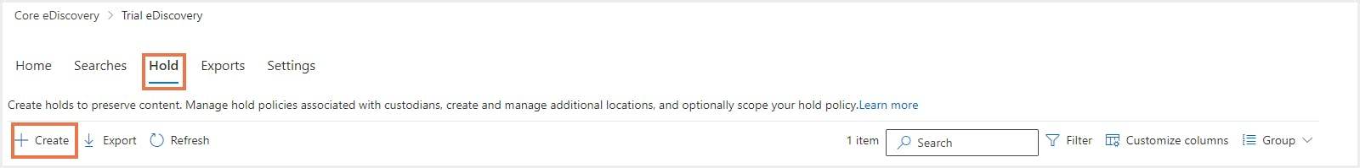

* **Step 5:** Enter a name for the hold and provide a description (optional). Click “Next”.
* **Step 6:**Choose the location (SharePoint sites, Exchange mailboxes or Exchange public folders). Click “Next”.

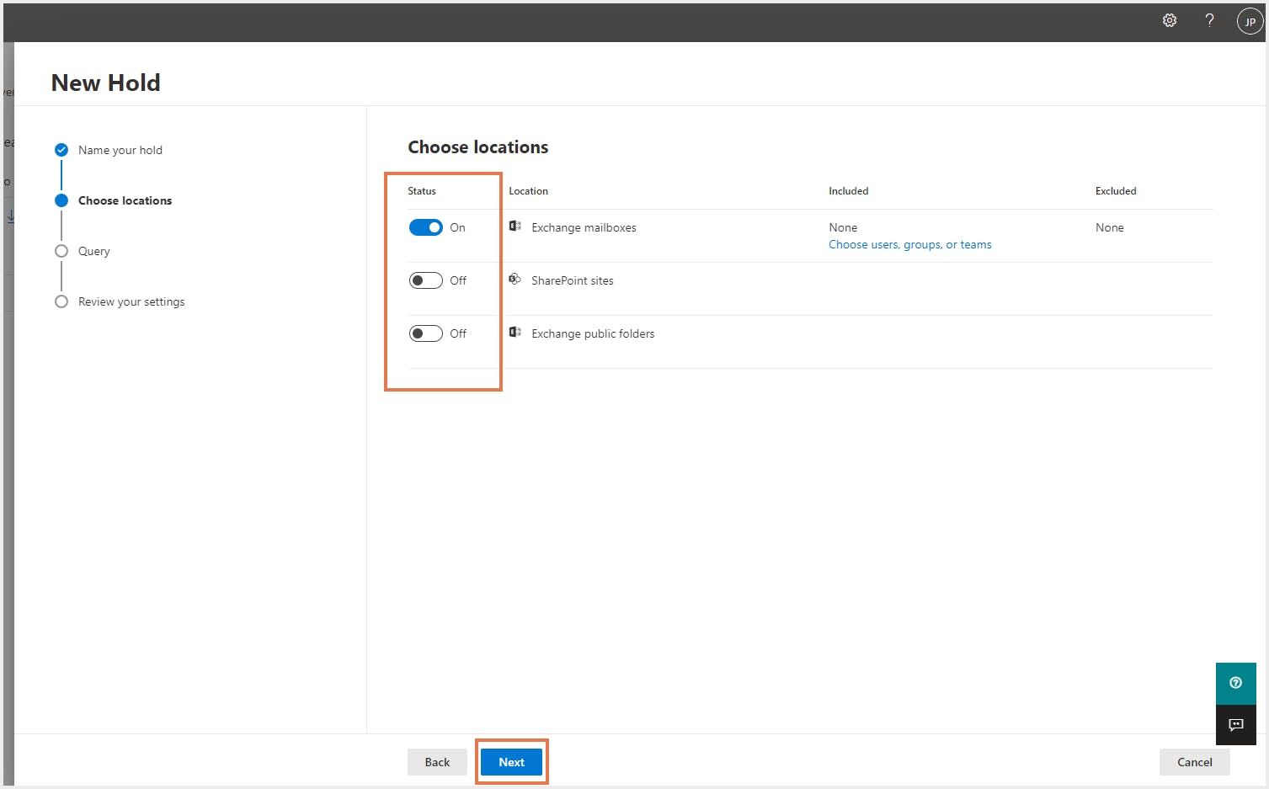

* **Step 7:**Enter the search query. Administrators can add a specific keyword and choose conditions to search for the query if needed.

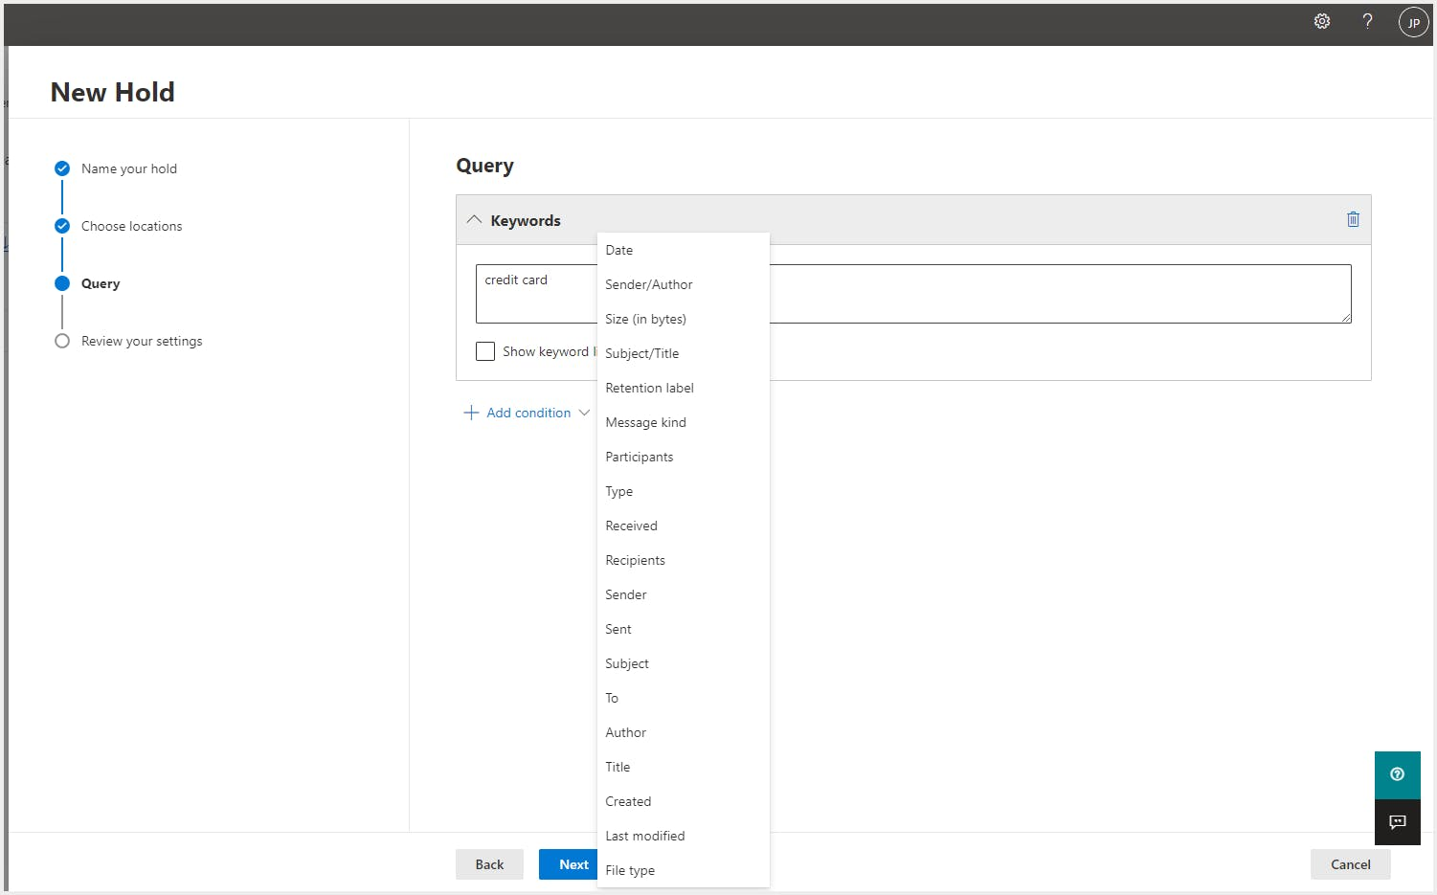

* **Step 8:** Review the settings and click “Submit”. The hold will be created based on the chosen location or the query and or condition.

It takes up to 24 hours for a hold to take effect.

Once the hold is in place, it can be removed by an administrator whenever needed. When a hold is removed, a 30-day grace period is applied (called a delay hold) to prevent the content from being deleted.